SELECT distinct Hotel_Ciudad, Hotel_Calle, Hotel_Nro_Calle, Hotel_CantEstrella, Hotel_Recarga_Estrella

FROM gd_esquema.Maestra

ORDER BY Hotel_Ciudad

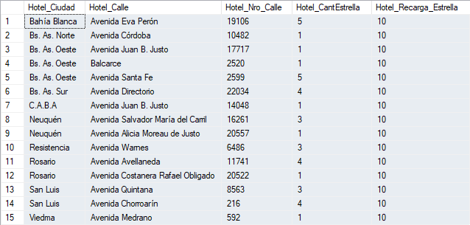

SELECT distinct Habitacion_Tipo_Codigo, Habitacion_Tipo_Descripcion, Habitacion_Tipo_Porcentual

FROM gd_esquema.Maestra

ORDER BY Habitacion_Tipo_Codigo

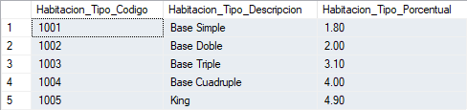

SELECT distinct Regimen_Precio, Regimen_Descripcion

FROM gd_esquema.Maestra

ORDER BY Regimen_Precio

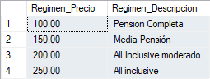

SELECT DISTINCT Consumible_Codigo, Consumible_Descripcion, Consumible_Precio

FROM gd_esquema.Maestra

WHERE Consumible_Codigo IS NOT NULL AND Consumible_Descripcion IS NOT NULL AND Consumible_Precio IS NOT NULL

ORDER BY Consumible_Codigo

